ORT Braude College
Software Engineering Department
Capstone Project Phase B – 61999
Autonomous Predictive Tracking and Laser Neutralization
System for Flies
Predictive Motion Modeling Component
26-1-R-22
By:
Daniel Lachmakov | Daniel.lachmakov@e.braude.ac.il
Yaniv Bodaga | Yaniv.bodaga@e.braude.ac.il
Advisors:
Dr. Dan Lemberg | Lembergdan@braude.ac.il
Mrs. Elena Kramer | Elenak@braude.ac.il
GitHub

September 2026

Table of Contents
Table of Contents 1
1. Problem Overview and Background 1
2. Project Description — What Was Done and Achieved 1
2.1 General Description 1
2.2 Solution Description — Research Method 1
Dataset 1
Feature representation 1
Movement clustering 1
Motion prediction model 1
Evaluation methodology 1
2.3 Research Process 1
2.4 Tools, Technologies, and Development Process 1
2.5 Challenges and Solutions 1
2.6 Results and Conclusions 1
2.7 Lessons Learned 1
2.8 Success Metrics — Did We Meet Them? 1
Appendix A — User Guide 1
A.1 Running via Google Colab (recommended) 1
A.2 Running locally 1
Appendix B — Maintenance Guide 1
B.1 Environment 1
B.2 File / Folder Layout 1
B.3 Extending the System 1
B.4 Known Limitations 1
References 1

1. Problem Overview and Background
Flies are a persistent nuisance in domestic, industrial, and laboratory settings, contributing to contamination and disruption of controlled environments. Their flight is extremely fast, irregular, and non-linear, with abrupt directional changes on the scale of tens of milliseconds. This makes flies a poor fit for automated tracking and interception systems, most of which assume smooth, continuous target motion.
As detailed in the Phase A report, classical tracking techniques such as Kalman and particle filters, and simple linear or polynomial motion extrapolation, all rely on assumptions of smooth motion that fly trajectories routinely violate. Reactive control, which aims at a target's currently observed position, is fundamentally limited by system latency: by the time a response is issued, a fast-turning fly has typically already moved elsewhere. This motivates prediction, not as an enhancement but as a necessity — a system must estimate where a fly will be a fraction of a second ahead, not where it currently is.
The Phase A literature review surveyed learning-based alternatives to classical motion models — in particular recurrent (LSTM/GRU) and Transformer-based sequence models — and identified relevant prior work: Transformer-based trajectory forecasting (TrajLearn), model-based fruit-fly tracking from high-speed video, and existing laser-based insect monitoring concepts. Phase A proposed a full system built around a Transformer-based predictor (adapted from TrajLearn) feeding a servo-actuated laser, with an independent, overriding human-detection safety mechanism.
Phase B narrows this scope to the core open question the rest of the system depends on: can a learned model actually predict a fly's short-horizon motion more accurately than the naive physics assumption a reactive system would otherwise fall back on — and if so, by how much, over what horizon, and for what kinds of movement? Answering this rigorously, on real fly trajectories rather than synthetic or assumed data, is the subject of this report.

2. Project Description — What Was Done and Achieved

2.1 General Description
The goal of this phase was to build and rigorously evaluate a predictive model of fly motion: given a short window of a fly's recent movement, predict where it will be a fraction of a second later, and quantify how much better that prediction is than the simplest reasonable alternative (assuming the fly keeps going in a straight line). This is the component shown as “Predict Future Fly Position” in the Phase A process flow (Figure 4 of the Phase A report) — everything downstream of it (laser alignment, actuation) depends on this prediction being both accurate and well characterised.
The intended consumers of this component are: (a) the laser-actuation subsystem, which would consume predicted positions as a control signal, and (b) the project team and evaluators, who need an honest, data-backed answer to “does prediction actually help, and where.” Rather than relying on a camera-and-laser test rig — not available at this stage of the project — the model was developed and evaluated end-to-end on a large, real, published dataset of fly trajectories, so that its accuracy numbers reflect genuine fly behaviour rather than a simplified simulation.

2.2 Solution Description — Research Method
This is a research-track component: the sub-sections below describe the algorithms and methodology used, rather than a deployable software architecture.

Dataset
All experiments use the Kim & Dickinson (Current Biology, 2017) Drosophila free-walking dataset: 11 recordings, 326 flies in total, each tracked at 60 Hz for up to about an hour, giving position, heading, and velocity per frame in an open arena. Flies spend the large majority of their time stationary or nearly so — the median frame-to-frame displacement across the raw data is about 0.02 mm, and roughly 68% of frames move less than 0.1 mm — so every analysis in this report operates on movement bouts: contiguous stretches where a fly's (smoothed) speed exceeds 2 mm/s for at least one second (60 frames).

Feature representation
To prevent the model from learning arena-specific habits (e.g. “flies tend to be near this wall”) instead of general flight dynamics, all motion features are expressed in a body-centred, rotation-invariant frame: for every frame, forward and lateral displacement are computed relative to the fly's own heading at that instant, rather than as absolute x/y coordinates. This principle is applied throughout both the clustering and prediction stages.

Movement clustering
To characterise what kinds of movement exist in the dataset — relevant to whether one predictive model should be expected to work equally well on every kind of fly movement — movement bouts were broken into 40-frame segments (~0.67 s), 15 evenly spaced per fly, each described by four rotation-invariant, z-scored features (sine and cosine of heading, speed, and angular velocity). These segments were clustered with soft-DTW time-series K-Means (tslearn), a distance measure suited to comparing motion segments that would not otherwise align frame-to-frame. The number of clusters k was swept from 2 to 15, and each clustering scored by its silhouette coefficient using a soft-DTW distance matrix (on a stratified sample of up to 1,200 segments per k, for tractability).
The best silhouette (k = 7, silhouette ≈ 0.075) was used to cluster the full set of 4,890 segments, producing 7 clusters of roughly 500–880 segments each. Silhouette scores in the 0.05–0.08 range are low in absolute terms, but this is expected and informative for behavioural data: fly movement is a continuum of turn sharpness and speed rather than a set of cleanly separated behaviours, so a modest peak indicates real, if soft, structure rather than a failure to cluster.
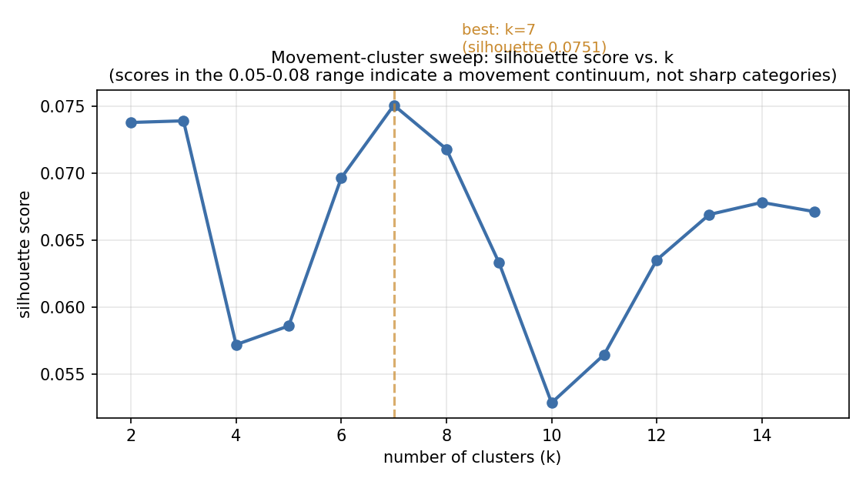
Figure 1. Silhouette score vs. number of clusters (k), full 326-fly dataset. k = 7 scores highest.

Motion prediction model
The predictive model is a 2-layer LSTM (64 hidden units per layer) followed by a small feed-forward head (64 → 64 → 2 with a ReLU non-linearity). Given the last 10 frames of a fly's movement (about 167 ms of history, each frame described by 5 body-centred features — forward step, lateral step, speed, angular velocity, and heading change), the model predicts the fly's displacement, forward and lateral, in its own reference frame at the last observed frame, over the next H frames ahead (the prediction horizon). Predicting a relative displacement rather than an absolute future position is deliberate: it forces the model to learn how a fly accelerates and turns — a pattern that should generalise across flies and arenas — rather than memorising where in this particular arena flies tend to end up.
Inputs are standardised (z-scored) using training-set statistics only. The model is trained with SmoothL1 loss (beta = 0.1, matched to the ~0.1 mm scale of a typical single-frame step — the default beta = 1.0 would behave like plain MSE at this scale and be oversensitive to rare large jumps from tracking noise), optimised with AdamW (learning rate 1e-3, batch size 512, gradient-norm clipping at 1.0). Training stops early once validation loss fails to improve for a set number of epochs, and the epoch with the best validation loss is kept as the final model, not necessarily the last epoch trained.
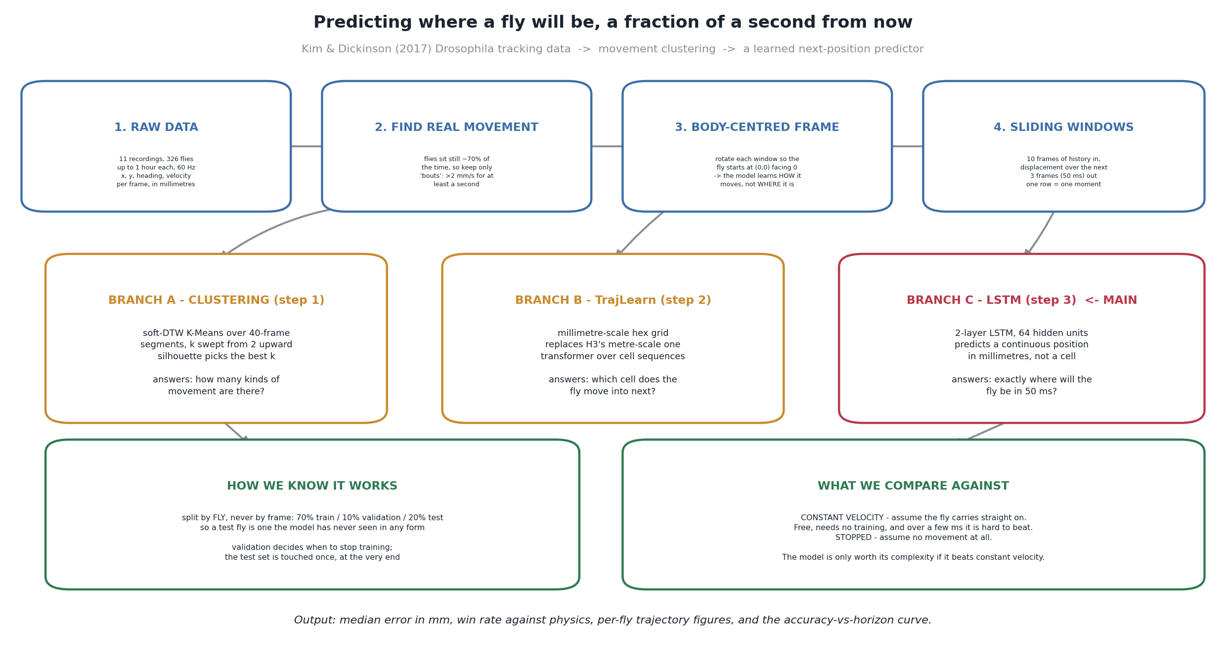
Figure 2. End-to-end pipeline: from raw tracking data to a trained next-position predictor.
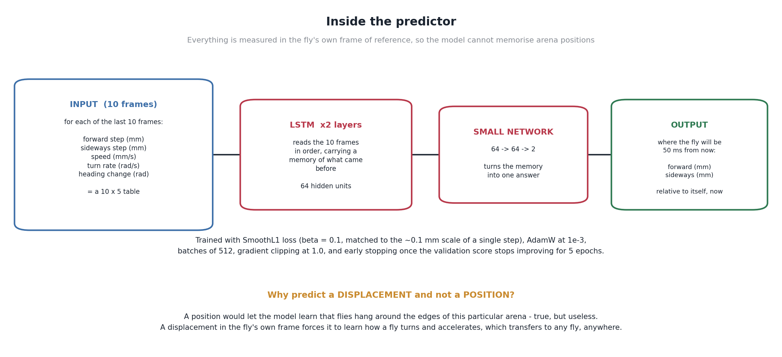
Figure 3. The prediction model: inputs, architecture, and training configuration.

Evaluation methodology
The 326 flies are split by fly, not by frame — 70% train, 10% validation, 20% test, with a fixed random seed for reproducibility — so that no fly's movement appears in more than one partition. This matters because consecutive frames from the same fly are highly correlated; splitting by frame instead would let the model see near-duplicates of test data during training and silently overstate accuracy.
Every model is compared against two baselines computed on the same data: constant velocity (assume the fly keeps its current speed and heading for the prediction horizon — the standard “no model at all” fallback a reactive system would use) and stopped (assume the fly does not move at all, which quantifies how much of the apparent accuracy is simply due to flies being slow most of the time). A model is only a worthwhile addition to the system if it beats constant velocity, since that baseline is free and needs no training.
Two complementary metrics are reported throughout: median error in millimetres (how far off a typical prediction is — chosen over the mean because a small number of large errors would otherwise dominate the average) and win rate (the percentage of individual test-set moments where the model's prediction landed closer to the truth than constant velocity did). The two can disagree — a model can have a better median error while still losing on more than half of individual moments — so both are always reported together.
To make “the model actually improves during training” a measured fact rather than an assumption, the full model state was snapshotted at epoch 0 (untrained, random weights) and every 5 epochs afterward, and every snapshot was scored on the same held-out test set. This produces a direct, per-epoch accuracy curve on data the model never saw during training or in the early-stopping decision (see Section 2.6).

2.3 Research Process
The research proceeded in five stages: (1) implementing a shared data-loading and feature-engineering module for the raw Kim & Dickinson CSVs, including movement-bout extraction and the body-centred feature transform used throughout; (2) the movement-clustering analysis (Section 2.2) to characterise the diversity of fly movement in the dataset; (3) an initial attempt at a Transformer-based trajectory predictor adapted from the TrajLearn architecture proposed in Phase A, tokenising trajectories for a generative, cross-entropy-trained decoder (Section 2.5 discusses why this approach was set aside); (4) design, training, and checkpoint-by-checkpoint evaluation of the continuous LSTM displacement predictor described above — first validated on a small subset of flies to confirm the pipeline was correct end-to-end, then scaled to the full 326-fly dataset; (5) a systematic sweep of the prediction horizon (about 17 ms to 500 ms) to characterise where the model's advantage over physics is largest, plus a breakdown of prediction error by movement cluster and by the fly's instantaneous speed and turn rate, to characterise not just how much the model helps but specifically when.

2.4 Tools, Technologies, and Development Process
Implementation is in Python: NumPy and pandas for data handling, PyTorch for the LSTM model, tslearn and scikit-learn for soft-DTW clustering and silhouette scoring, and Matplotlib/Seaborn for all figures. Training and the full-dataset horizon sweep (the most compute-intensive steps) were run on Google Colab using its GPU runtime, via a notebook that drives the same scripts used for local/CPU development and testing, with per-step timing and resumability (e.g. the horizon sweep resumes from whichever horizons have already completed) so a multi-hour run survives a disconnected session.
There was no external client for this research-track component; the development “client interface” was iterative review with the project advisors, who set the direction of evaluating prediction quality on real data with an honest, baseline-referenced measure of improvement rather than isolated accuracy claims.

2.5 Challenges and Solutions
Choosing the wrong unit of analysis, twice. Frame-level features (absolute x/y, compass heading) let the model memorise arena-specific habits instead of general flight dynamics, and an early split-by-frame evaluation setup let information leak between train and test because consecutive frames from one fly are nearly identical. Both were corrected before any accuracy numbers were trusted: features were switched to a body-centred, rotation-invariant frame, and the train/validation/test split was moved to the fly level (Section 2.2).
Architecture: TrajLearn transformer vs. a continuous LSTM regressor. Phase A proposed adapting TrajLearn, a Transformer encoder-decoder that predicts trajectories as a distribution over discretised spatial tokens, trained with cross-entropy loss. Two problems emerged applying this to fly motion specifically: fly displacements are small and continuous (typically well under a millimetre per frame), so discretising them into tokens either loses the precision the project needs or requires an impractically fine-grained vocabulary; and a full generative Transformer decoder is data- and compute-hungry relative to what a single-lab, single-species dataset and a Colab GPU session can support. The project pivoted to a simpler, continuous-output 2-layer LSTM trained by direct regression on displacement — a smaller computational commitment, more naturally matched to physical position prediction, at the cost of the explicit multi-modal uncertainty modelling TrajLearn offers (Section 2.7 discusses this trade-off).
Fly movement is mostly nothing. With roughly 68% of raw frames essentially stationary, training or evaluating on all frames mostly measures “predict no movement,” a poor guide to real performance. Resolved by explicitly filtering to movement bouts (sustained speed above 2 mm/s) at every stage of analysis.
Evaluating training progress fairly. A loss curve alone does not demonstrate the model getting better against the baseline it needs to beat. Every saved checkpoint, not just the final model, is scored on the same held-out test set, producing a direct accuracy-vs-epoch curve rather than a proxy for one (Section 2.6).
Compute constraints. Model training and the full horizon sweep across 326 flies and 5 horizons are multi-hour jobs, and no local GPU was available. The pipeline runs identically locally (CPU, for development and testing on a data subset) and on Google Colab (GPU, for the full run), with environment-variable configuration and per-step resumability so a long run is not lost to a disconnected Colab session.
Reporting a null or weak result honestly. At very short prediction horizons, “the fly kept going the way it was already going” is nearly unbeatable, so it was a real risk that the learned model would show little to no advantage. Rather than tuning the horizon after the fact to find a flattering number, the horizon sweep (Section 2.6) was run across a full range and the crossover point reported as the finding, whichever direction it came out.

2.6 Results and Conclusions
At the horizon that turned out to be most favourable for the learned model (50 ms, three frames ahead — see the horizon sweep below), the LSTM predictor achieves a median error of 0.0229 mm on the test set (65 flies, never seen during training or model selection), against 0.1218 mm for the constant-velocity baseline: an 81.2% reduction in typical error. Individually, the model lands closer to the truth than constant velocity on a median of 95.3% of test-set moments across the 65 test flies (mean 95.2%), and even the single worst-performing test fly still wins on 88.8% of its moments — no test fly is a case where the model fails outright.
Split | # flies | % of total
Train | 228 | 69.9%
Validation | 33 | 10.1%
Test | 65 | 19.9%
Table 1. Fly-level train / validation / test split (326 flies total).
Table 2 and Figure 4 show this is not an accident of picking 50 ms after the fact: across the horizons tested (about 17 ms to 500 ms), the model's advantage over physics rises to a clear peak at 50 ms (81.2%) and falls off on both sides — 63.4% at 17 ms and 65.0% at 100 ms, dropping further to 47.1% and 42.6% at 250 ms and 500 ms.
Horizon | LSTM median error (mm) | Physics baseline (mm) | Improvement
16.7 ms (1 frame) | 0.0129 | 0.0352 | 63.4%
50 ms (3 frames) | 0.0229 | 0.1218 | 81.2% (peak)
100 ms (6 frames) | 0.0881 | 0.2519 | 65.0%
250 ms (15 frames) | 0.3584 | 0.6780 | 47.1%
500 ms (30 frames) | 0.8882 | 1.5465 | 42.6%
Table 2. Model accuracy vs. the physics baseline, across prediction horizons (full 326-fly test set).
This pattern has a straightforward physical reading: at very short horizons, a fly has barely had time to change what it was already doing, so “keep going the same way” is already a strong guess and there is less room for a learned model to add value. At very long horizons, a fly has had enough time to turn or stop that neither method predicts it well, but the physics assumption decays faster than the learned model does. The 50 ms peak sits in between: long enough for constant velocity to start missing genuine turns, short enough that the model's 167 ms of input history is still highly informative.
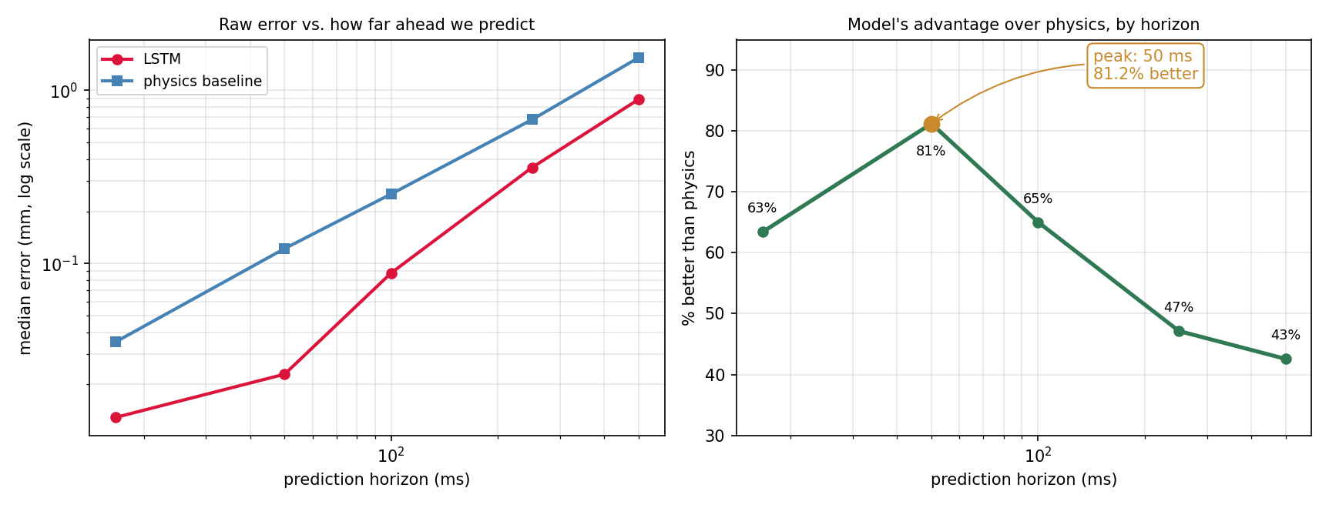
Figure 4. Left: raw median error vs. prediction horizon (log scale). Right: the model's percentage advantage over physics, peaking at 50 ms.
Figure 5 confirms the model actually learns this from training data, checkpoint by checkpoint, on the held-out test set: the untrained model (epoch 0, random weights) is far worse than physics (0.509 mm median error, beating physics on only 2.1% of moments — worse than a coin flip, as expected from random weights). By epoch 5 it has already crossed over to 0.024 mm and a 95.2% win rate, and the numbers stay essentially flat (0.023 mm, ~95.3–95.5% win rate) from epoch 10 through epoch 25, where training stopped early (best validation loss at epoch 19, no improvement for 6 further epochs). This is direct, measured evidence that training is what produces the accuracy, not an artefact of the architecture or of a weak baseline.
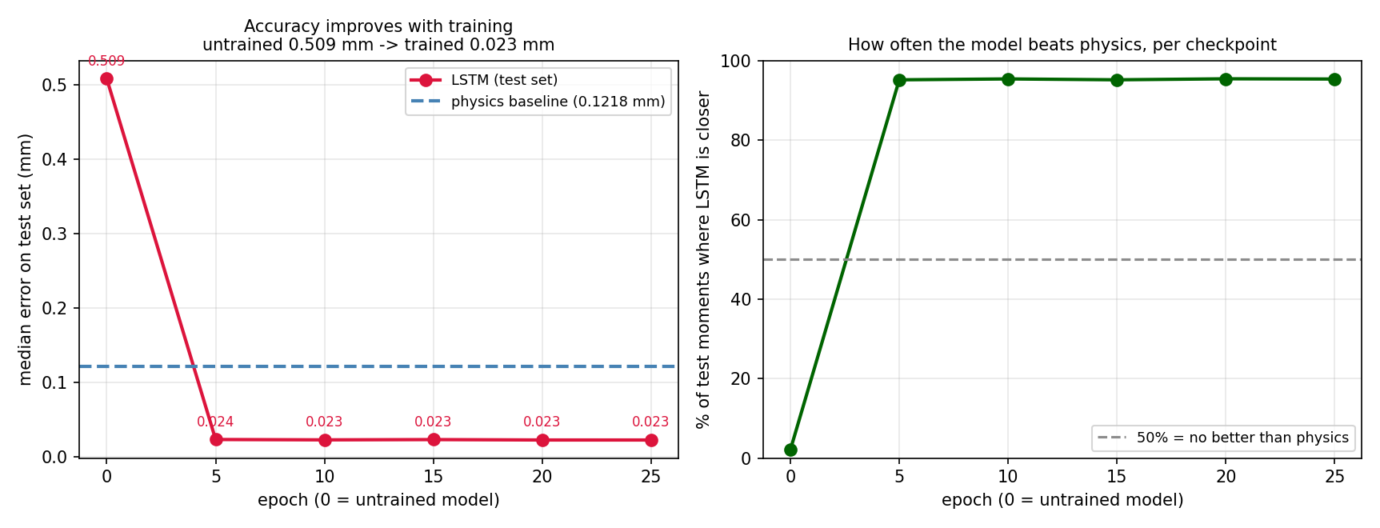
Figure 5. Test-set accuracy at each saved checkpoint (epoch 0 = untrained). Left: median error vs. epoch. Right: win rate vs. epoch.
Figure 6 connects this back to the movement-clustering analysis: the model's advantage over physics is consistent across all seven movement clusters found in the data, from 73.4% (the smallest, most unusual cluster) to 80.8% — no cluster is a case where the learned model fails to help. Combined with the low but positive silhouette scores from clustering, this supports treating fly movement as a continuum the model generalises across, rather than a set of distinct behaviours some of which it happens to handle well and others not.
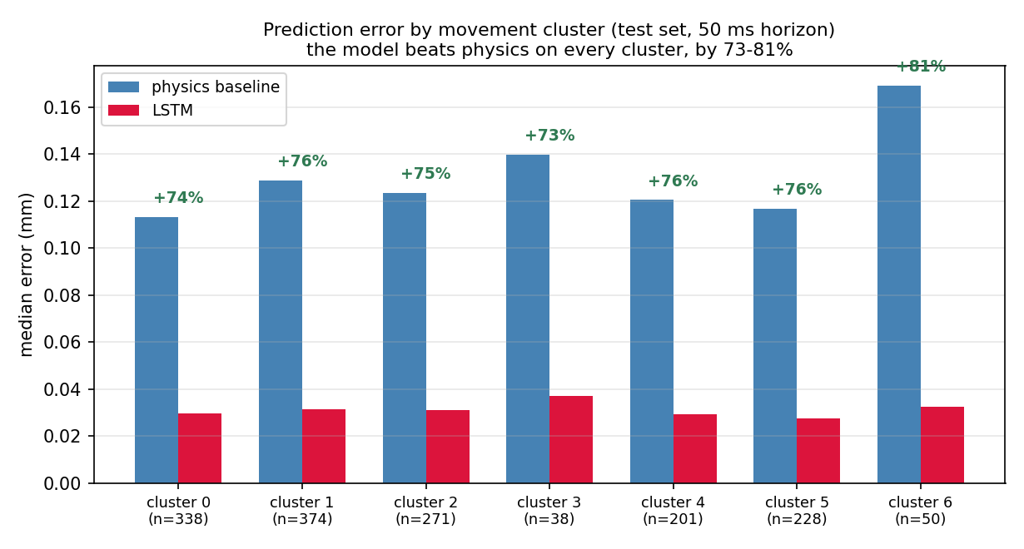
Figure 6. Prediction error by movement cluster (test-set moments assigned to their nearest cluster centroid, 50 ms horizon).
Held against the project's own success criteria (Phase A, Section 5.2): accurate motion prediction was demonstrated with a large, consistent margin over the reactive baseline (81.2% at the best horizon, never worse than 42.6% at any tested horizon); robustness and generalisability were demonstrated across all seven independently discovered movement clusters and across the full range of fly speeds and turn rates without manual per-condition tuning; and the comparison is honest in the sense required by the metrics defined in Phase A — error measured against ground truth, on a held-out set the model never touched during training or model selection. Two Phase A criteria were not exercised in this phase, because they concern the hardware system rather than the prediction model in isolation: autonomous, real-time end-to-end operation (camera → detection → prediction → laser), and noise/uncertainty tolerance under live sensor conditions rather than the dataset's own (already-present) tracking noise. These remain to be demonstrated once the prediction model is integrated with the perception and actuation components developed separately.

2.7 Lessons Learned
Architecture choice should follow the data's actual shape, not the literature's default. TrajLearn's discrete, generative, multi-modal design is well suited to problems like vehicle trajectory forecasting, where genuinely multi-modal future paths matter (a car can turn left, right, or go straight at an intersection). Fly displacement prediction over a fraction of a second is a much narrower problem — a continuous, mostly uni-modal regression — and a smaller model matched to that shape trained faster, on less data, and produced accuracy numbers that were straightforward to validate. In hindsight, prototyping the simplest reasonable baseline model earlier, rather than committing to the more complex architecture proposed in Phase A first, would have saved time.
Baselines are not a formality. Reporting every result against constant-velocity and stopped baselines, on the same data and the same held-out flies, was what turned “the model works” into a specific, falsifiable, and ultimately more convincing claim — and it is also what surfaced the horizon-dependent result (Section 2.6) that a single accuracy number at one arbitrary horizon would have hidden entirely.
Splitting by the right unit matters more than it looks. The by-fly split required more care to implement than a simple random frame split, but a frame-level split would have silently inflated every number in this report through train/test leakage. This is a general lesson for any project working with correlated, sequential data.
If repeating this phase, more time would be allocated up front to defining the evaluation protocol — splits, baselines, metrics — before any model-architecture work, rather than in parallel with it; several of the fixes above amount to evaluation-protocol issues discovered after initial modelling had already started.

2.8 Success Metrics — Did We Meet Them?
Table 3 maps each success criterion defined in the Phase A report (Section 5.2) to the outcome of this phase.
Phase A criterion | Status | Evidence
Accurate motion prediction | Met | 81.2% median-error reduction vs. physics at 50 ms; 42.6–81.2% across all tested horizons
Robustness / generalisability | Met | 73.4–80.8% improvement across all 7 movement clusters; worst test fly still wins 88.8% of moments
Adaptability to diverse scenarios | Met | Explicit movement-bout filtering handles stationary periods; consistent gains across the full range of observed speeds and turn rates
Noise / uncertainty tolerance | Met (dataset-level) | Trained and evaluated on real tracked positions, including the dataset's own measurement noise; live-sensor noise not yet exercised
Autonomous real-time operation | Not yet exercised | Depends on integration with the perception/actuation hardware, developed separately; this phase measured prediction accuracy only
Table 3. Phase A success criteria vs. Phase B outcome.

Appendix A — User Guide
This guide describes the normal, successful workflow for reproducing the movement-clustering and motion-prediction analysis in this report. It assumes the reader has the 11 Kim & Dickinson (2017) Drosophila CSV files, and either a Google account (for the Colab route, recommended) or a local Python 3.10+ environment (for the local route). Error handling and recovery from failed steps are intentionally not covered here — see Appendix B (Maintenance Guide) for environment setup and troubleshooting.

A.1 Running via Google Colab (recommended)
- Upload the 11 dataset CSV files and the project's Python scripts (fly_common.py, 01_cluster_ksweep.py, 02_prepare_trajlearn.py, 03_continuous_model.py, 04_report_figures.py, 05_horizon_figure.py, 06_architecture_diagram.py) to a single folder in Google Drive.
- Open Fly_Project_Colab.ipynb in Google Colab and mount Google Drive when prompted.
- In the Settings cell, point the notebook at the Drive folder from the previous step, choose an output folder name, and choose a run mode: quick (a small subset of flies, for a fast sanity check) or medium/full (the complete dataset, roughly 2–4 hours depending on the GPU allocated).
- Run the notebook cells in order, from Step 0 through Step 6. Each step prints its own progress and elapsed time, and writes its outputs to the chosen output folder. Later steps (clustering, the horizon sweep) resume automatically if the notebook is re-run after a disconnection, rather than starting over.
- When Step 6 completes, the output folder contains: per-model accuracy tables (prediction_results.csv, epoch_checkpoints.csv, horizon_sweep.csv), the trained model weights and checkpoints (next_step_lstm.pt), the clustering assignment (fly_segments_clustered.csv, cluster_centroids.npy), every figure referenced in this report, and one trajectory figure per fly under per_fly_trajectories/.

A.2 Running locally
- Install the required Python packages (see Appendix B).
- Place the 11 CSV files in a single data folder.
- From that folder (or with the FLY_DATA_DIR environment variable set to it), run, in order: 01_cluster_ksweep.py, 02_prepare_trajlearn.py, 03_continuous_model.py, 04_report_figures.py, 05_horizon_figure.py, 06_architecture_diagram.py.
- Outputs are written to an outputs/ folder next to the scripts (or the folder set by FLY_OUTPUT_DIR), in the same layout as the Colab route.

Appendix B — Maintenance Guide

B.1 Environment
- Python 3.10 or later.
- Required packages: numpy, pandas, matplotlib, seaborn, torch (2.0+; a CUDA build is recommended but not required), tslearn, scikit-learn.
- Install with: pip install numpy pandas matplotlib seaborn torch tslearn scikit-learn (or the project's requirements file in the GitHub repository, if present).
- Hardware: a GPU is strongly recommended for 03_continuous_model.py (model training) and 05_horizon_figure.py (which retrains the model at each of several horizons); every other script runs comfortably on CPU. Google Colab's free GPU runtime is sufficient for the full 326-fly dataset.

B.2 File / Folder Layout
- fly_common.py — shared configuration and data loading (frame rate, movement-bout detection thresholds, raw-CSV parsing); every other script imports this.
- 01_cluster_ksweep.py through 06_architecture_diagram.py — the six pipeline stages, run in numeric order (each depends on outputs from earlier stages except 06, which is data-independent).
- Fly_Project_Colab.ipynb — the same pipeline wrapped for Google Colab, with Drive mounting, run-mode presets, and per-step timing/resume logic.
- Outputs are written to a single configurable output folder (outputs/ by default; FLY_OUTPUT_DIR overrides this), never back into the source data folder.

B.3 Extending the System
- To add more fly data: place additional CSVs matching the existing column schema (fly, time(s), position_x/y(mm), velocity_x/y(mm/s), heading(radians), velocity_heading(radians/s)) in the data folder; no code changes are required.
- To explore a different prediction horizon: set FLY_HORIZON (in frames; the dataset runs at 60 Hz, so FLY_HORIZON=3 is 50 ms) before running 03_continuous_model.py, or use 05_horizon_figure.py to sweep several horizons at once.
- To change the number of movement clusters considered: set FLY_K_MIN / FLY_K_MAX before running 01_cluster_ksweep.py.
- Key training settings (max epochs, early-stopping patience, checkpoint frequency) are environment-variable-configurable (FLY_MAX_EPOCHS, FLY_PATIENCE, FLY_CHECKPOINT_EVERY); see the header comments in 03_continuous_model.py for the complete list.

B.4 Known Limitations
- Validated on a single species and dataset (Drosophila, Kim & Dickinson 2017); accuracy numbers should not be assumed to transfer to other species or camera setups without re-evaluation.
- The PyTorch training path was developed and validated end-to-end on Google Colab; it was not separately verified across every possible local OS/CUDA combination.
- This component predicts motion only; it has no connection yet to the live camera, human-detection safety system, or laser actuation described in the Phase A system design — those are integrated separately by the project partner.

References
- A. J. Kim and M. H. Dickinson. Free-walking Drosophila trajectory dataset. Current Biology, 2017. (Exact article title/volume to be confirmed against the published source before final submission.)
- Amirhossein Nadiri, Jing Li, Ali Faraji, Ghadeer Abuoda, and Manos Papagelis. TrajLearn: Trajectory prediction learning using deep generative models. arXiv:2501.00184, 2025.
- See the Phase A report (Autonomous Predictive Tracking and Laser Neutralization System for Flies, December 2025) for the full literature review and additional references.

